DEEP Robotics: Jueying x30 Quadruped

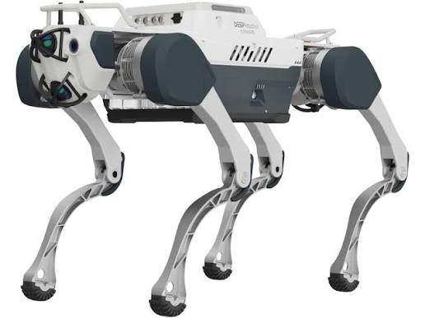

Legacy file created December 2026
by 7th semester robotics group 760

This document will focus on operating the x30 quadruped robot by DEEP Robotics.

Some preliminary notes that could be important for projects utilizing the X30 robot.
- The robot only has support for ROS 1 Noetic.
- If different height levels are important for the semester project, then be aware the robot has some difficulties walking up stairs even in "stair mode".
- There are specific ROS packages for the lidar sensors and the IMUs, but not for the visual camera sensor (as far as we could see).
- Two manuals for use of the robot:
https://blog.althumans.com/wp-content/uploads/2026/07/deeprobotics-x30-pro-user-manual-ver2.0.5-0.pdf
https://blog.althumans.com/wp-content/uploads/2026/07/deeprobotics-x30-pro-application-manual.pdf

Connection/communication
The ways to communicate with the robot are presented in the manual below
https://blog.althumans.com/wp-content/uploads/2026/07/deeprobotics-x30-pro-application-manual.pdf

Windows:
The way to communicate with the robot is presented i

Linux:

Control

Sensors

